## **CREATING THE DATABASE AND TABLES**

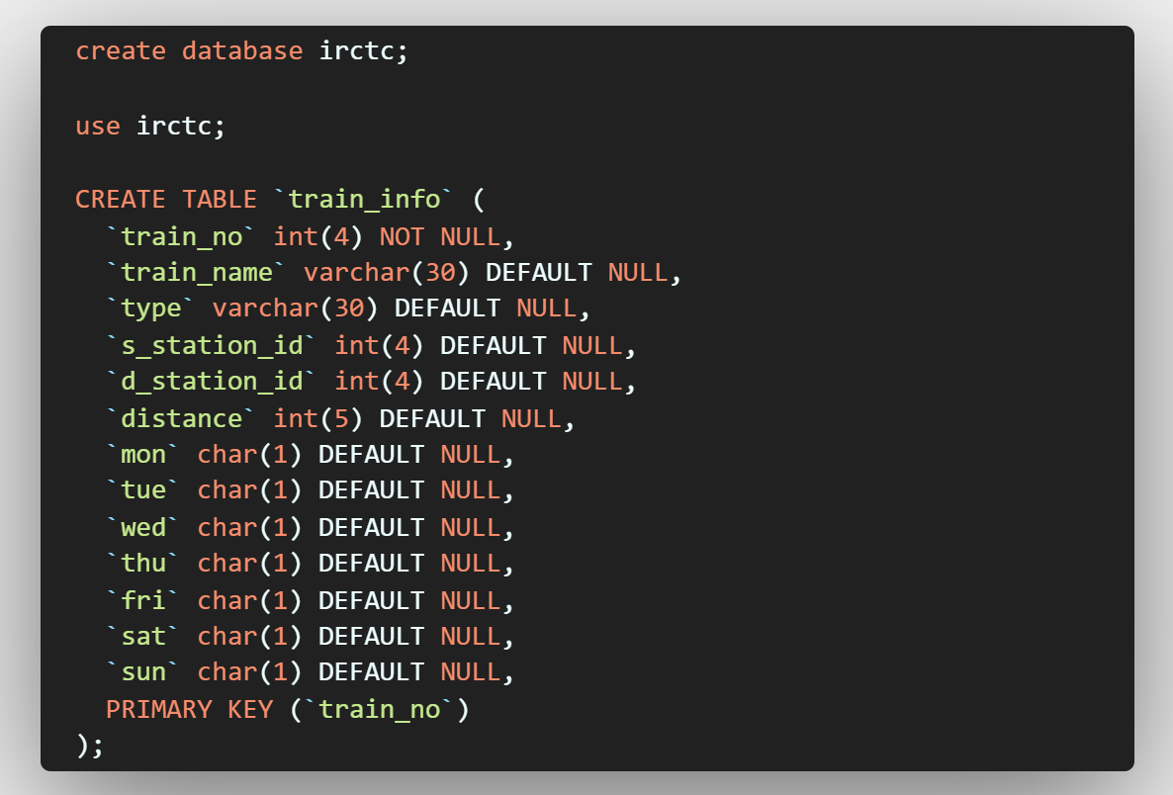

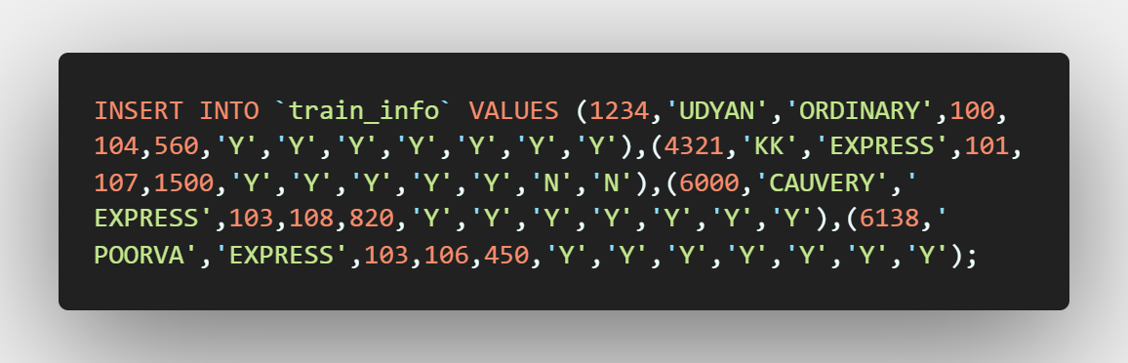

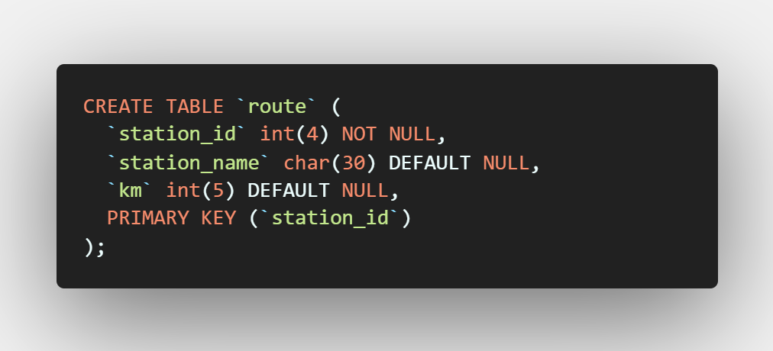

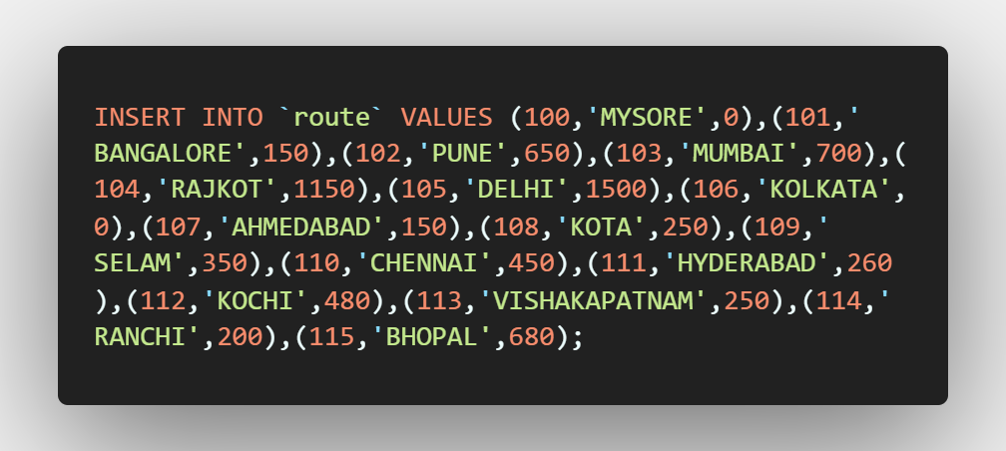

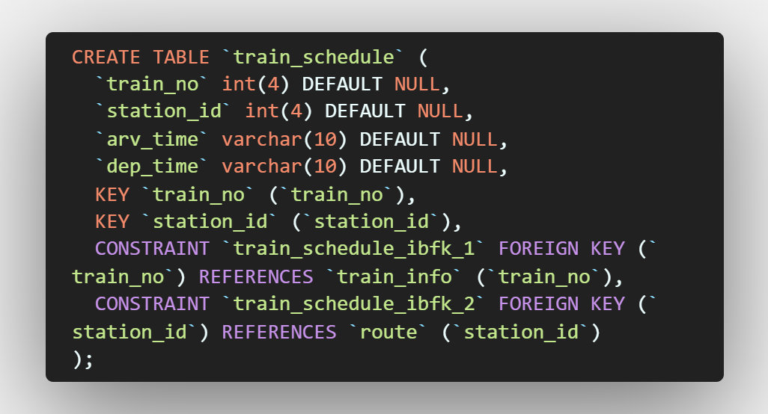

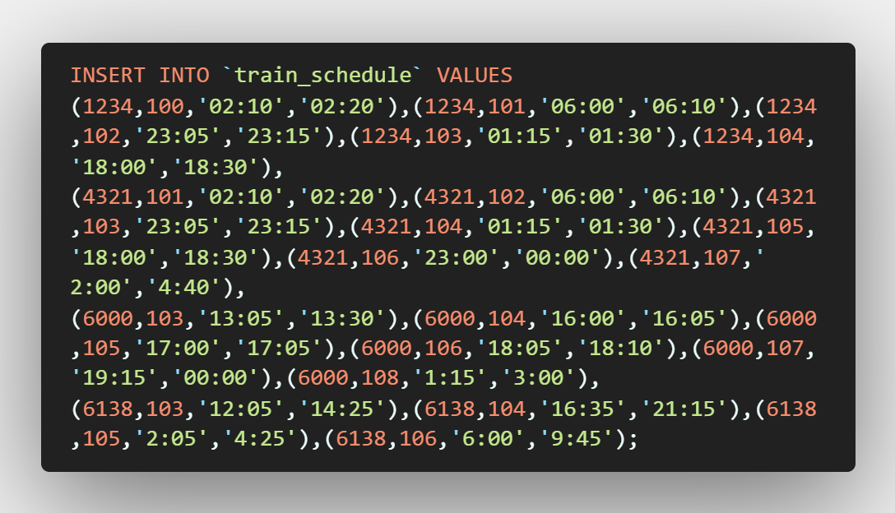

# **QUERIES**

MariaDB [irctc]> show tables;

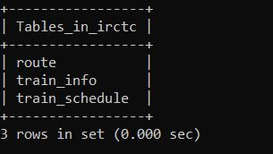

MariaDB [irctc]> desc route;

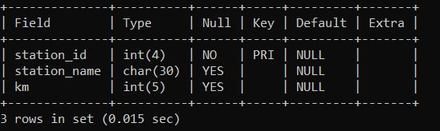

MariaDB [irctc]> desc train_info;

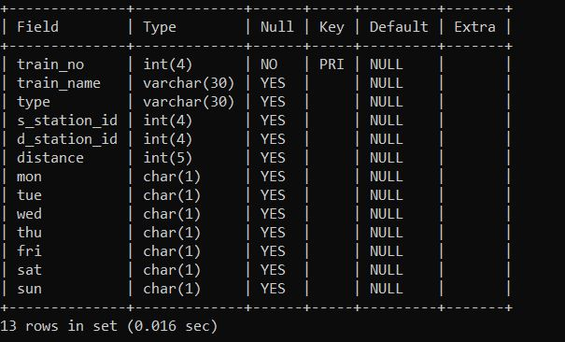

MariaDB [irctc]> desc train_schedule;

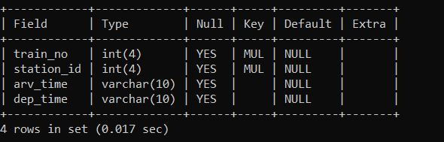

MariaDB [irctc]> select ti.train_no as 'TRAIN NO.',ti.train_name as 'TRAIN NAME',ti.type as 'TRAIN TYPE',ti.s_station_id as 'SOURCE STATION CODE',ti.d_station_id as 'DESTINATION STATION CODE',ti.distance as 'DISTANCE(IN KM)',ti.mon,ti.tue,ti.wed,ti.thu,ti.fri,ti.sat,ti.sun,ts.arv_time as 'ARRIVAL TIME',ts.dep_time as 'DEPARTURE TIME' from train_info ti,train_schedule ts where s_station_id<= (select station_id from route where station_name like 'PUNE') and d_station_id >=(select station_id from route where station_name like 'MUMBAI') and ti.train_no=ts.train_no and ts.station_id>=(select station_id from route where station_name like 'PUNE') and ts.station_id<(select station_id from route where station_name like 'MUMBAI');

